LATHOM PARISH COUNCIL

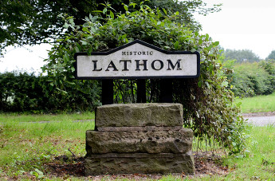

ANNUAL PARISH ASSEMBLY
FOR THE PARISH OF LATHOM

MONDAY AT 7.30 P.M. ON 19TH MAY 2025
Minutes

Present: H Shaw (Chair)
E Pope
I Fairclough
A Sherman
L McDonnell
M McDonnell

Apologies: A Beckett

1. The Chair welcomed everyone to the meeting which opened at 7.30 p.m.

2. The Minutes of the Annual Parish Assembly Meeting May 2024 have previously been reviewed and approved.

3. The Chair gave a report for the year which included:-

- Thanking Parish Clerk D Abram for providing good governance for the year.
- Thanking Councillor Sherman for being the lead for all PROW items.
- Thanking Councillor M McDonnell for being the lead on the SPID camera and analysing the data from the same.
- Thanking all Councillors who had responded fairly and appropriately per their obligations and the statutory regulations for each planning application that had arisen whilst also listening to the views of residents and reflecting their concerns appropriately to the Planning Department when required.
- The Chair thanked all Parish Councillors for their attendance and voluntary work during the year.

Items that had been covered during the year include:-
- Rebuilding the Lathom sign at Wanes Blades Bridge.
- Maintenance of the noticeboard (The Ship Inn).
- Attending the Remembrance Day Service.
- The increase in residents attending meetings to discuss planning applications was appreciated by all Councillors to assist them in forwarding all views to the Planning Department.

Finally, a big thank you is passed to the litter picking team volunteers for clearing up the fly tipping and general litter within Lathom.

The Chair’s wish for the next year include:-
- Seeking local residents views and concerns for the area they live in including traffic issues, plans for the future of Lathom and all other relevant local issues that arise.
- Ensuring the Civic Service takes place during 2025.

4. It was agreed that election of the Chair and Vice Chair would take place at the next available Parish Council Meeting due to the minimum number of Parish Councillors attending this meeting and the same would be minuted as part of the monthly Parish Council Minutes.

5. No other business was raised.

6. The meeting closed at 7.40 p.m.

Signed …………………………………………………………………… Dated …………………………………

